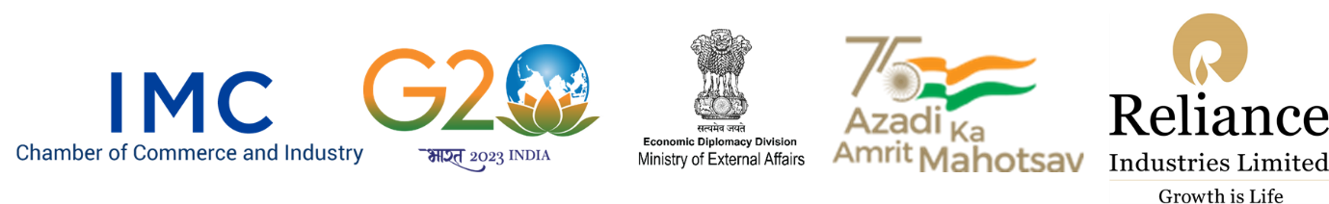

IMC INDIA CALLING CONFERENCE 2023
Rising India – Inviting Partnership for Growth

Saturday, 29 April 2023
Venue: Hotel Taj Santacruz, Mumbai
Hybrid format

Registration Form

Name of the Company: ________________________________________________________

Address of the Company: ________________________________________________________

________________________________________________________

Country: ________________________________________________________

Business Area: ________________________________________________________

DELEGATE DETAILS
Sr No. | Delegate Name | Designation | Email ID | Contact Number

Kindly send the registration form duly filled to vanita.ghuge@imcnet.org

For any further queries contact Mr. Sanjay Mehta, Deputy Director General +919930241006 or write to sanjaymehta@imcnet.org.

The joining link for access to the Conference will be sent to you closer to the date of Conference.

